Dissertation dev log
Week 10:
Current Goals for prototype session:
- Readme that highlights development roadmap
Current Strech goals for prototype:
- Voronoi clipping implemented
- A way to interact with the fragmented mesh
- An implementation in GLSL, for performance comparison
Completed:
- A working Voronoi fracture in 2D for demonstration
- Working Voronoi fracture in 3D
- Comprehensive background done, covering triangulation, fracturing methods used in games, Graphics API’s, Performance of Graphics API’s, Point sampling, and Voronoi Clipping.
- Clearly stated research question
- Clear, feasible hypothesis, that is well scoped.
- An introduction that provides clear context for the project, and explains the need for the research, including positive impacts and who benefits. It should also highlight the motivation for the project.
- Professional, ethical, sustainable, legal, and social review carried out.
- A plan for security and privacy concerns has been written, and data is well managed.
- A methodology for how the project is going to be researched, and how its going to be evaluated
- A working way of profiling the results of the prototype
- A Critical Review of current technology is completed, that highlights where the gap in research is, and the how this project fills it.
- Project is ethically robust
- Project plan with gantt chard
- Profiling results that are easily replicated and are well documented.
- Fracture implemented in both OpenGL and Vulkan

Development notes:
Gannt project plan completed. It was challenging to decide how long the task next term are going to take, but research into the relevant techniques allowed me to make good estimates. Vulkan Voronoi diagram implemented, and started on Delaunay triangulation, implemented in 2D, but still needs work for 3D. Finished my computing artefact and testing and validation sections. Implemented code for performance testing, creating a box plot and running my test using python. Also created c++ code for recording my data to json. Changed to using json to record data instead of excel as it would be clearer, as otherwise recording data per API was messy. Added example code snippets.
Images:
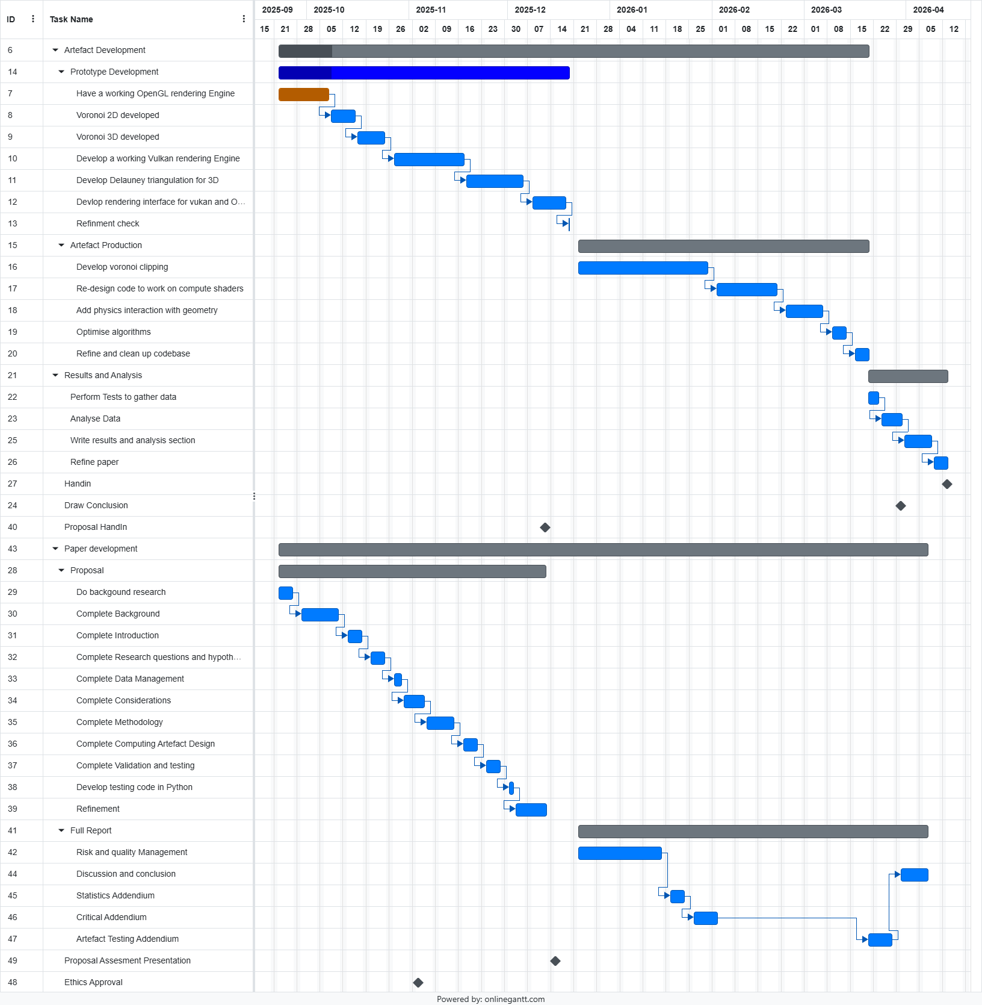

References:

